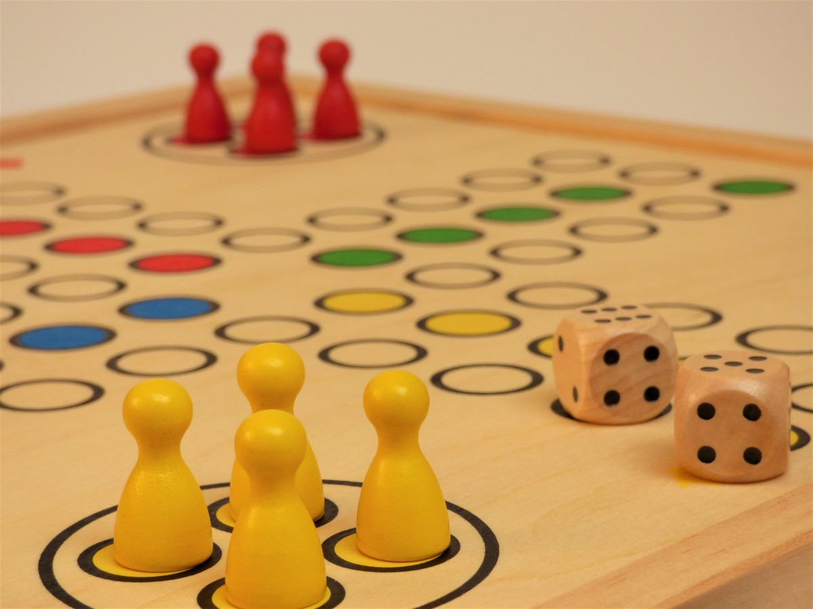

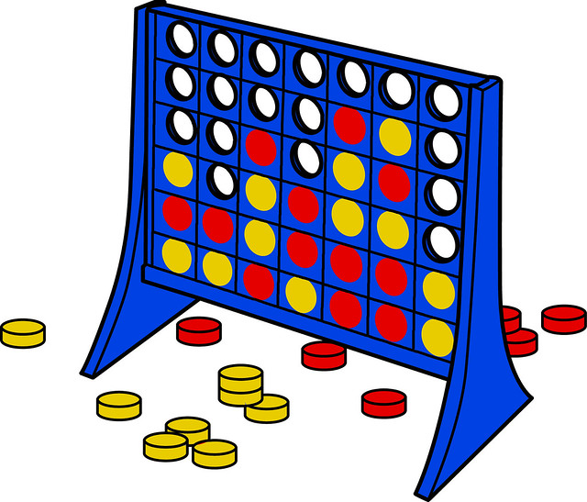

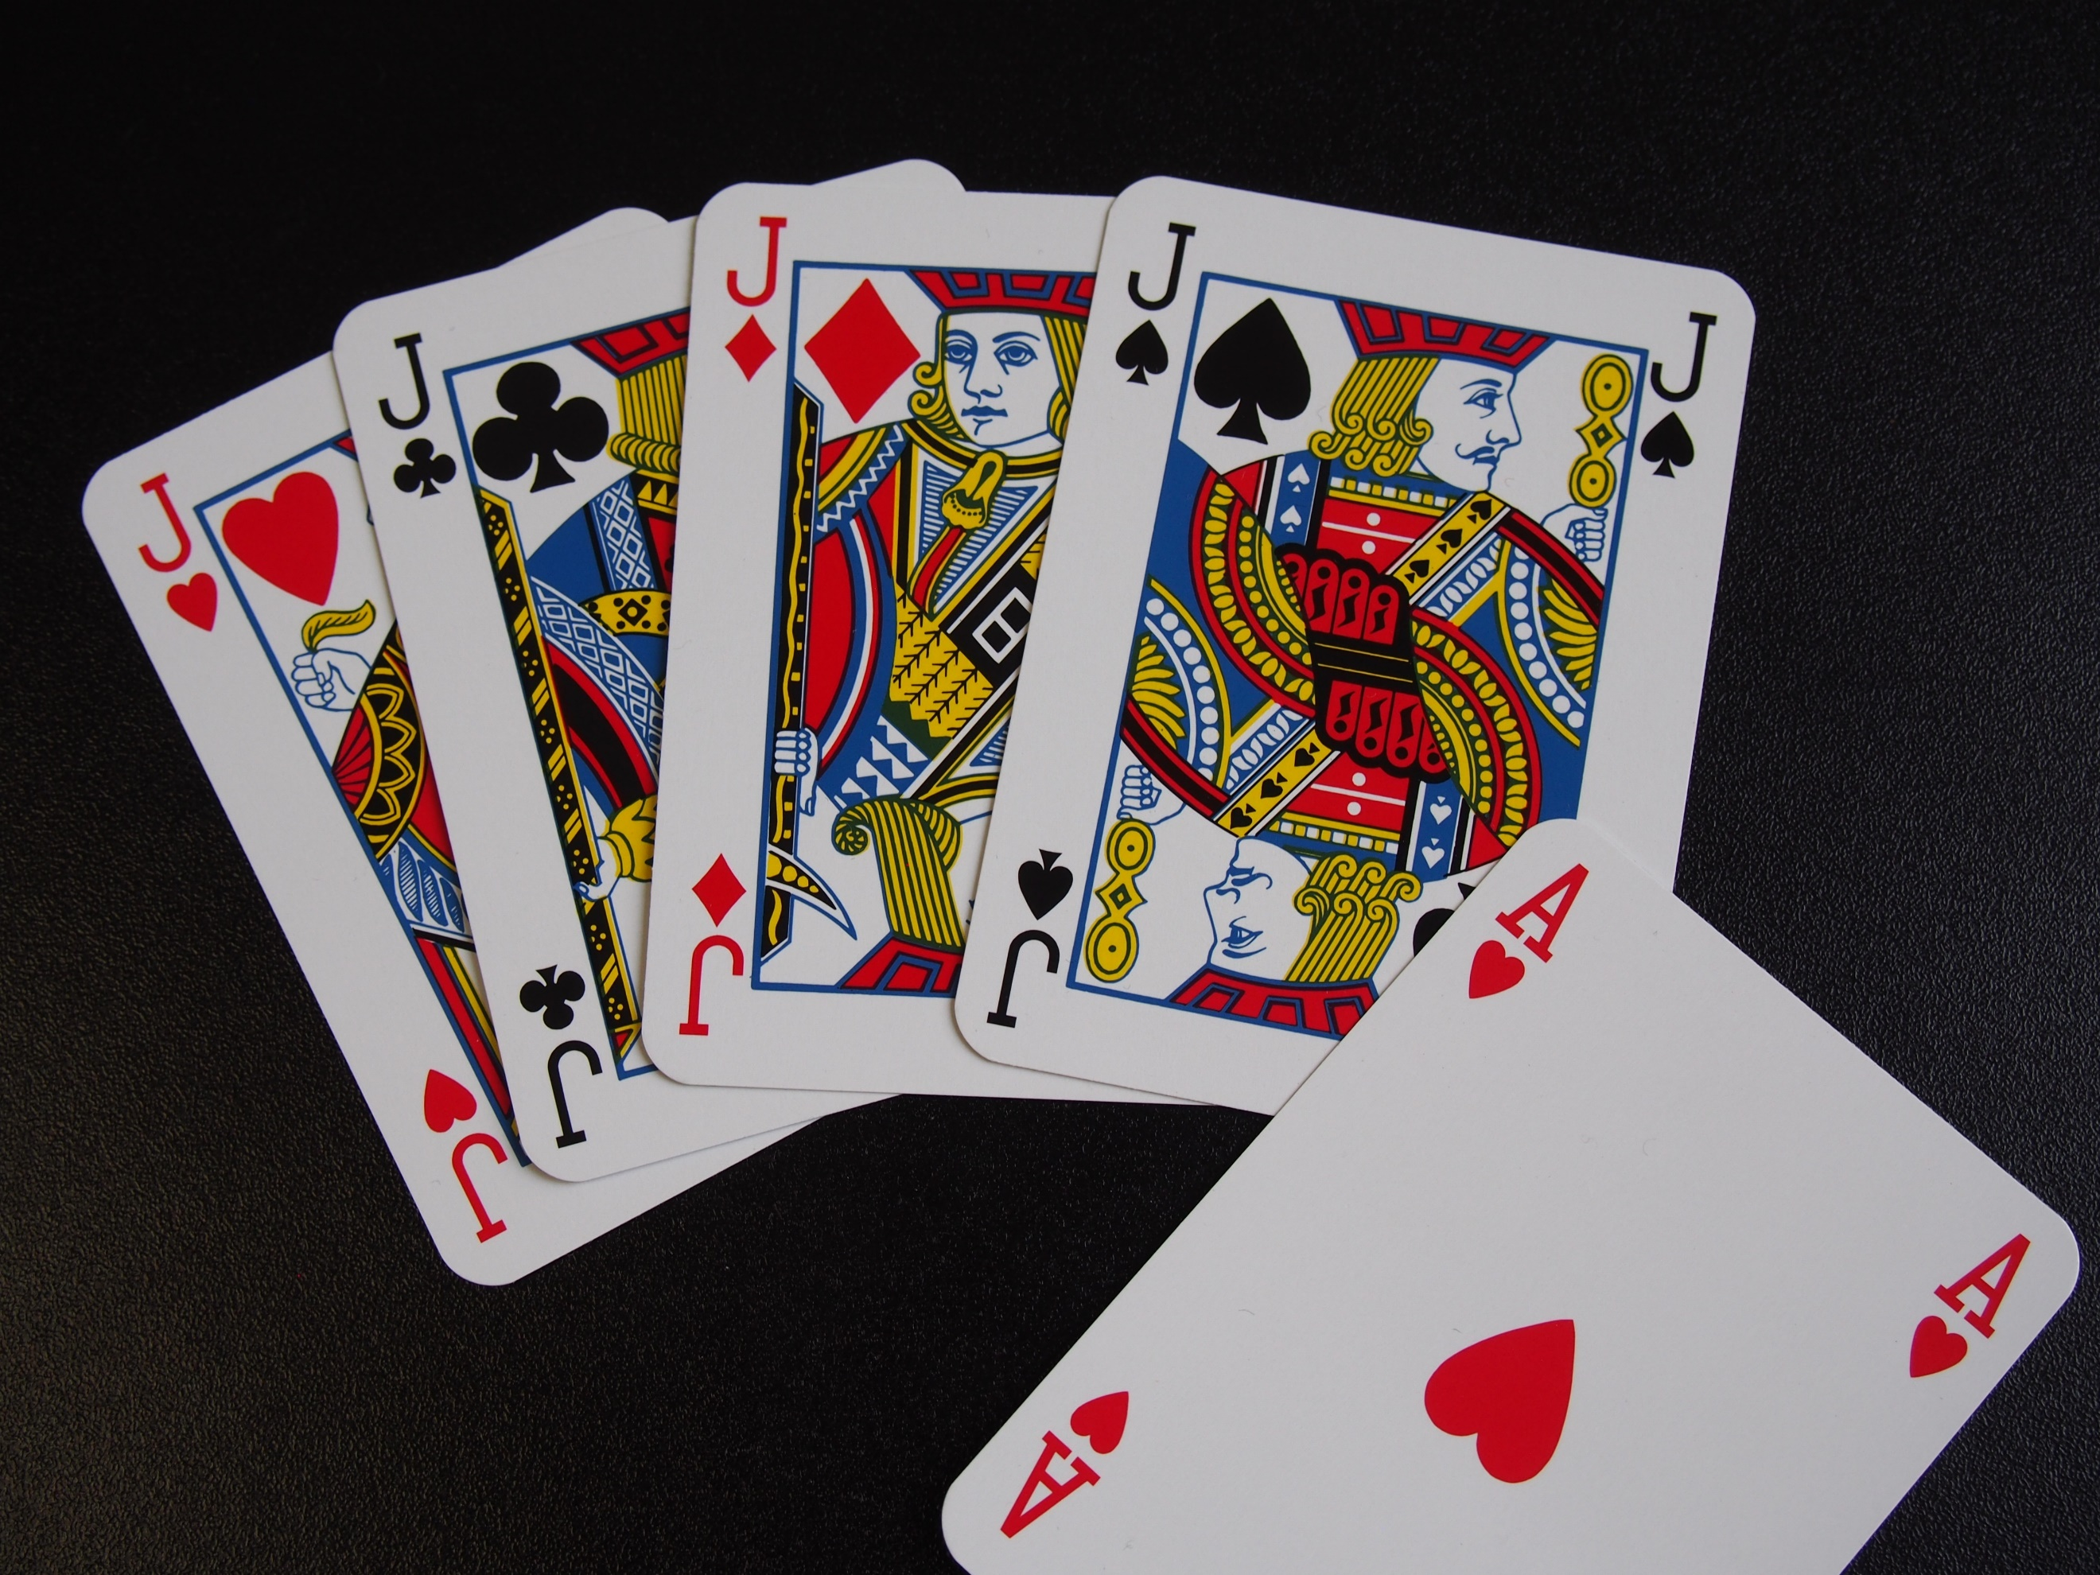

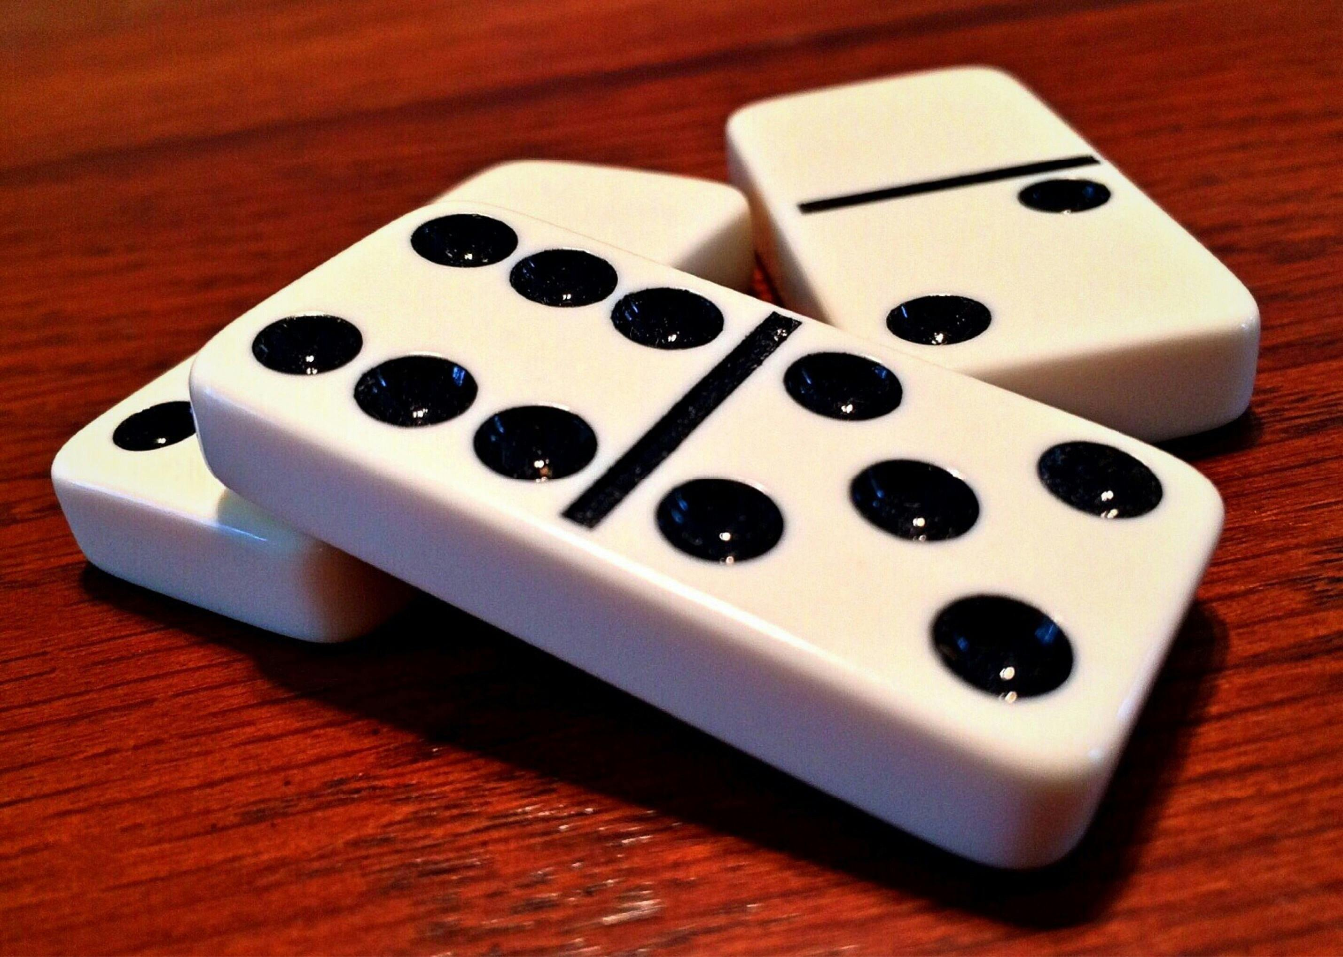

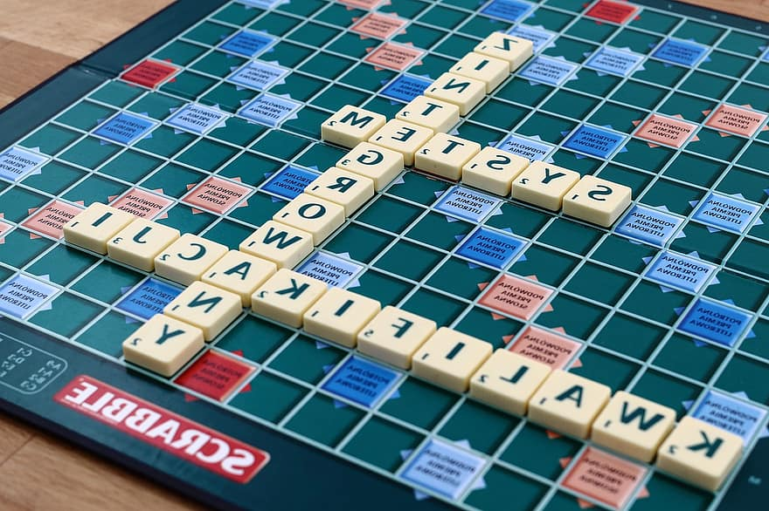

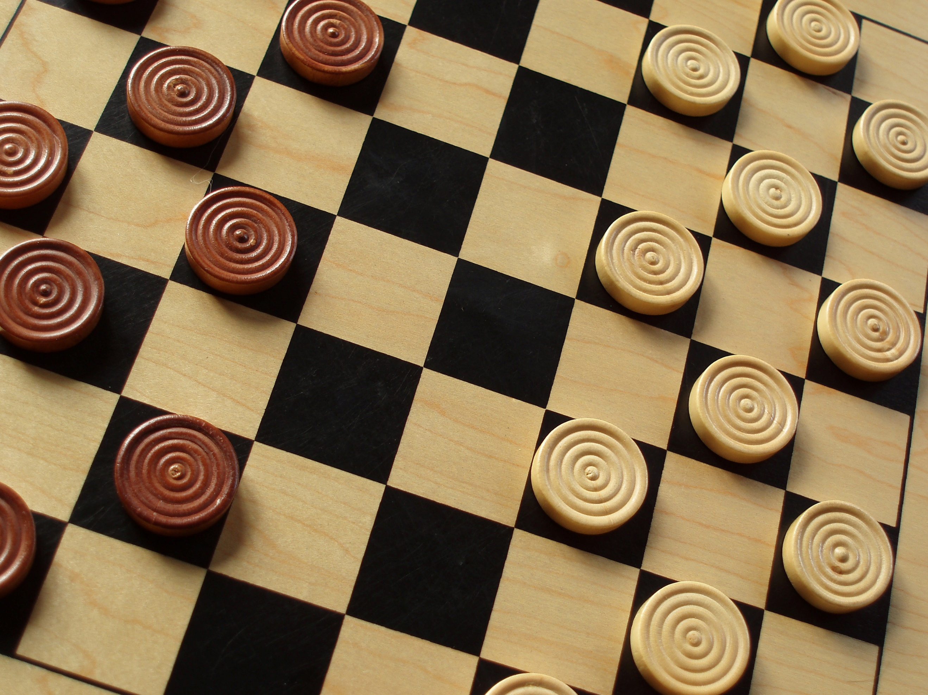

**Tea & Biscuits * Free Entry * Raffle**

**MAWBRAY VILLAGE HALL**

**Come and Join us to enjoy an afternoon of fun playing some popular board games**

**Sunday 20th October 2024**

**2pm – 4pm**